Descriptive Data

Juan Maldonado Franco
Department of Technology, National University
DDS-8500: Principles of Data Science
Dr. Javier E. León
1/13/2026

Descriptive Data
This report presents an exploratory data analysis (EDA) of a structured dataset containing demographic, socioeconomic, and behavioral variables, including age, gender, education level, employment status, income, and self-reported happiness. The purpose of this analysis is to summarize and explore the key characteristics of the data using descriptive statistics and visual representations prior to conducting any inferential or predictive modeling.
Exploratory data analysis plays a central role in modern data science by supporting an iterative process of data transformation, visualization, and interpretation that enables analysts to understand distributions, identify patterns, detect anomalies, and assess data quality (Wickham et al., 2010). In this study, the dataset was first cleaned and structurally corrected to address missing values, schema misalignment, and data type inconsistencies. Following this preparation, descriptive statistics and graphical techniques were applied to examine both numerical and categorical variables.
The primary goal of this report is to extract meaningful descriptive insights regarding the distribution of key variables, the variability within the data, and the relationships between selected categorical attributes. These findings provide a foundational understanding of the dataset and inform future analytical steps, including hypothesis testing and predictive analysis.
Data Presentation
The dataset used in this analysis consists of 500 observations, each representing an individual record. The data include both numerical and categorical variables spanning demographic characteristics, educational attainment, employment status, income, and subjective well-being. After the data cleaning and structural correction phase, the dataset contained 16 variables, excluding identifiers used solely for indexing.
Numerical variables include Age, Height, Weight, Income, Score, and Happiness. These variables are measured on either ratio or interval scales and allow computation of measures such as the mean, median, standard deviation, and range (Kaliyadan & Kulkarni, 2019). Categorical variables include Gender, Education, Marital Status, Employment, Rating, Category, Color, Hobby, and Location, which are measured on nominal or ordinal scales.
The sample size of 500 observations is appropriate for descriptive analysis, as it provides sufficient representation across categories while allowing stable estimation of summary statistics. Although missing values are present, they were intentionally preserved during exploratory analysis to accurately reflect the structure and limitations of the original data.
A structured table summarizing variable types and measurement scales is included to support clarity and transparency in the presentation of the dataset.
Descriptive Statistics
Descriptive statistics were computed for all numerical variables to summarize central tendency, variability, and distributional shape. The variables analyzed included Age, Height, Weight, Income, Score, and Happiness.
Age exhibited a narrow distribution with a mean of 28.44 and a median of 28, indicating minimal variability across the sample. Income demonstrated substantially greater dispersion, with a mean of 52,408.98 and a significant standard deviation of 9,271.09, highlighting meaningful differences in economic status among participants. Happiness scores were moderately concentrated, with a mean of 7.64 and relatively low variability.
Across all numerical variables, skewness and kurtosis values suggested approximately symmetric distributions with no extreme deviations. These results indicate that the data are well-suited for further exploratory and inferential analysis.
Descriptive Questions
Based on the initial data exploration and descriptive statistics, the following descriptive research questions were developed to guide the exploratory analysis:
1. What is the distribution of Age within the dataset, and how much variability exists among participants?
2. How is Income distributed across the sample, and does it exhibit greater dispersion compared to other numerical variables?
3. How does educational attainment vary by Gender within the dataset?
4. How is Employment status distributed across demographic groups?
These questions focus on both single-variable characteristics and relationships between categorical variables. Prior research in data analytics suggests that demographic attributes such as education, employment, and income are closely associated with socioeconomic outcomes and well-being. Exploring these relationships descriptively provides essential context before performing inferential or predictive analysis.
Visual Representations
Visual representations were used to complement descriptive statistics and to provide intuitive insight into the structure, distribution, and relationships within the dataset. Graphical methods allow patterns and differences to be identified more easily than numerical summaries alone, particularly when communicating findings to non-technical audiences (Knaflic, 2020). The following figures and tables present visual summaries of both numerical and categorical variables examined in this exploratory analysis.
Numerical Variable Distributions
Histograms and boxplots were created for numerical variables to examine distributional shape, central tendency, variability, and potential outliers.
Age Distribution
The distribution of Age was examined using a histogram to visualize the frequency of observations across age values.
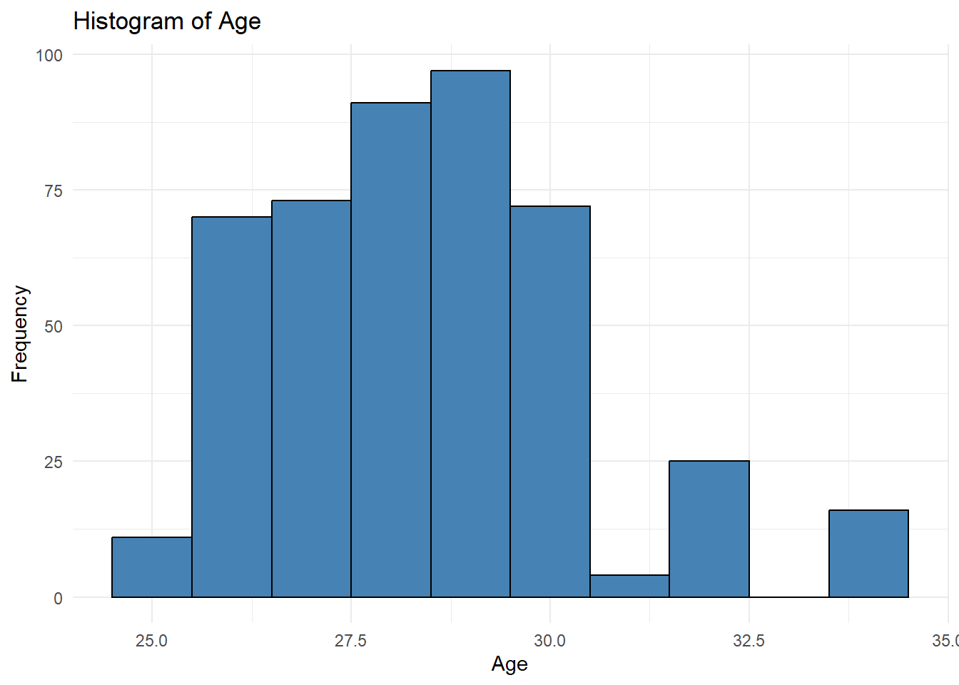
Figure 1
Histogram of Age
The histogram shows that Age values are tightly clustered within a narrow range, with most observations concentrated in the late twenties. This confirms the descriptive statistics, which show that the mean and median were nearly identical. The distribution appears approximately symmetric with a slight right skew, and no extreme age values are evident.
To further assess variability and outliers, a boxplot of Age was generated.
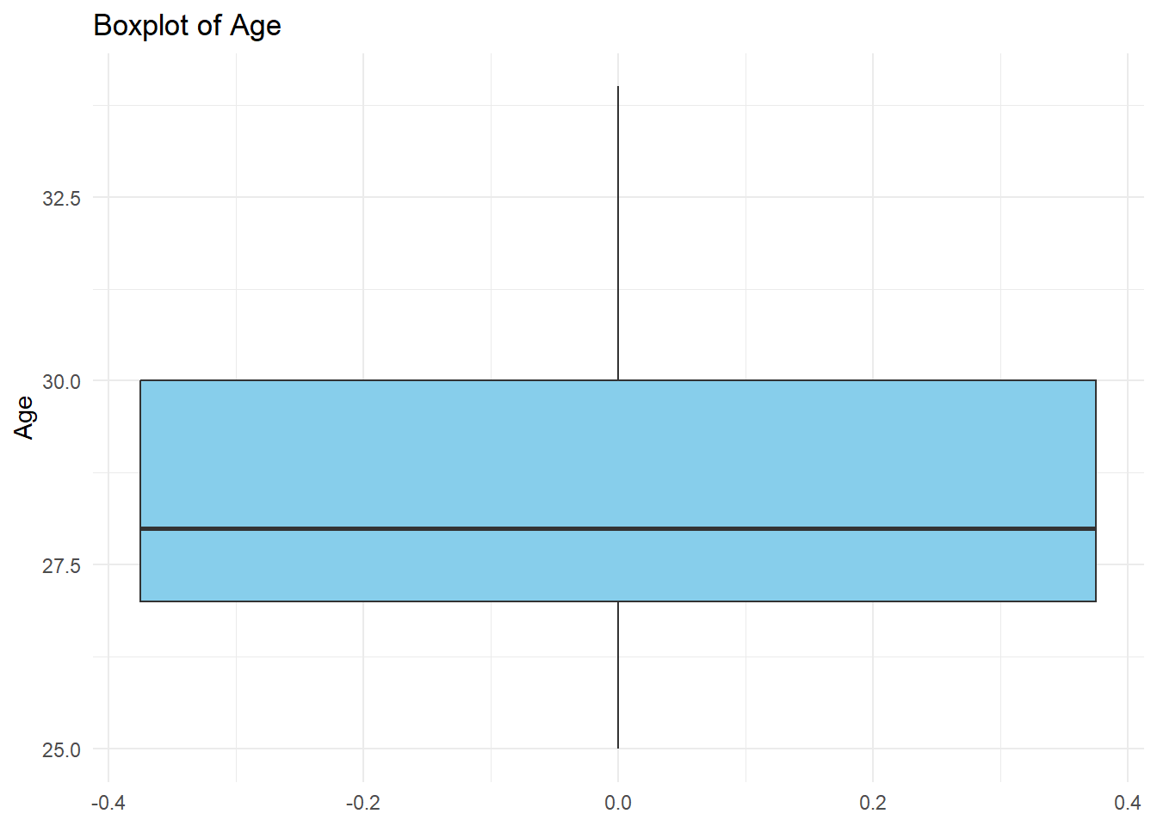
Figure 2
Boxplot of Age
The boxplot shows a small interquartile range (IQR), indicating that the middle 50% of Age values are closely grouped. The median is centrally located within the box, and no significant outliers are present. This reinforces the conclusion that Age exhibits limited variability within the dataset.
Income Distribution
Income was analyzed using a histogram to capture its broader range and higher variability relative to other numerical variables.
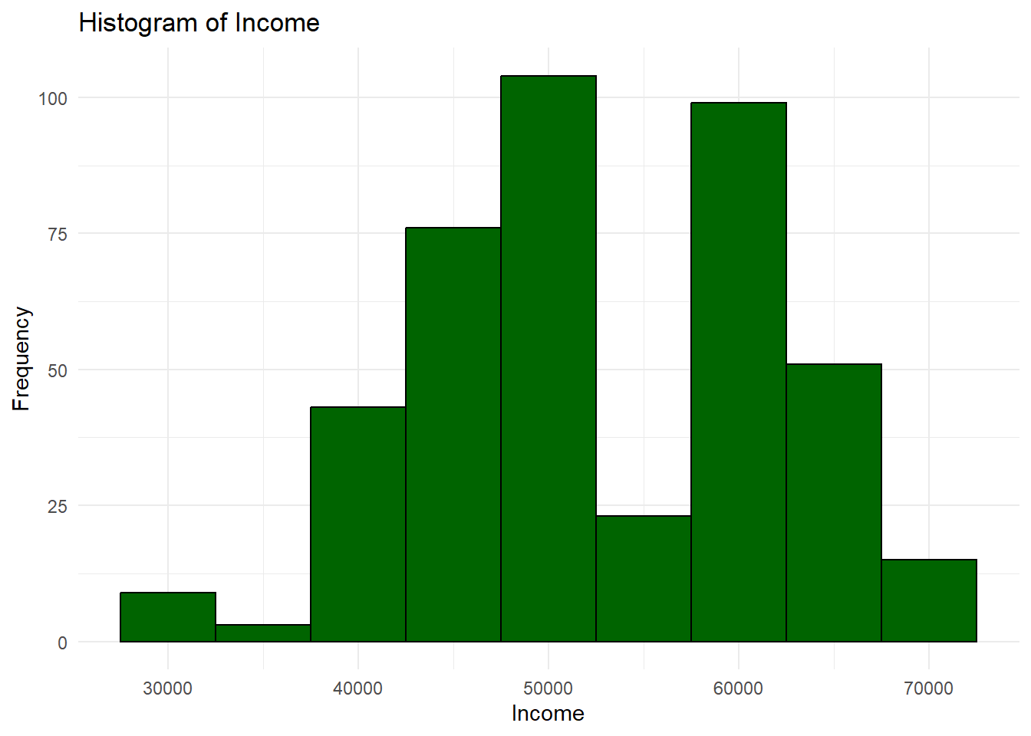
Figure 3
Histogram of Income
The histogram reveals a wider spread of Income values, with observations distributed across multiple income brackets. While the distribution is approximately symmetric, the greater dispersion indicates meaningful differences in economic status among participants. This visual pattern aligns with the high standard deviation observed in the descriptive statistics.
A boxplot was used to evaluate income variability and potential outliers further.
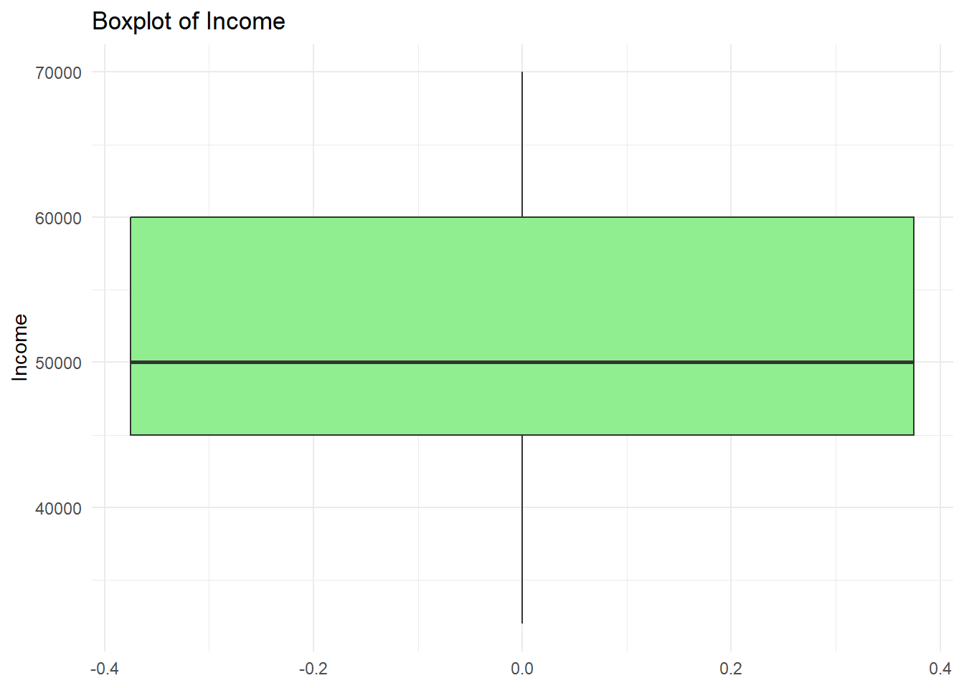
Figure 4
Boxplot of Income
The boxplot confirms that Income has the largest IQR among the numerical variables analyzed. Several values appear at the upper end of the distribution, though no extreme outliers are present. The wide spread suggests that Income may play a more influential role in differentiating outcomes in future analyses.
Happiness Distribution
Happiness scores were visualized to assess overall well-being levels within the dataset.
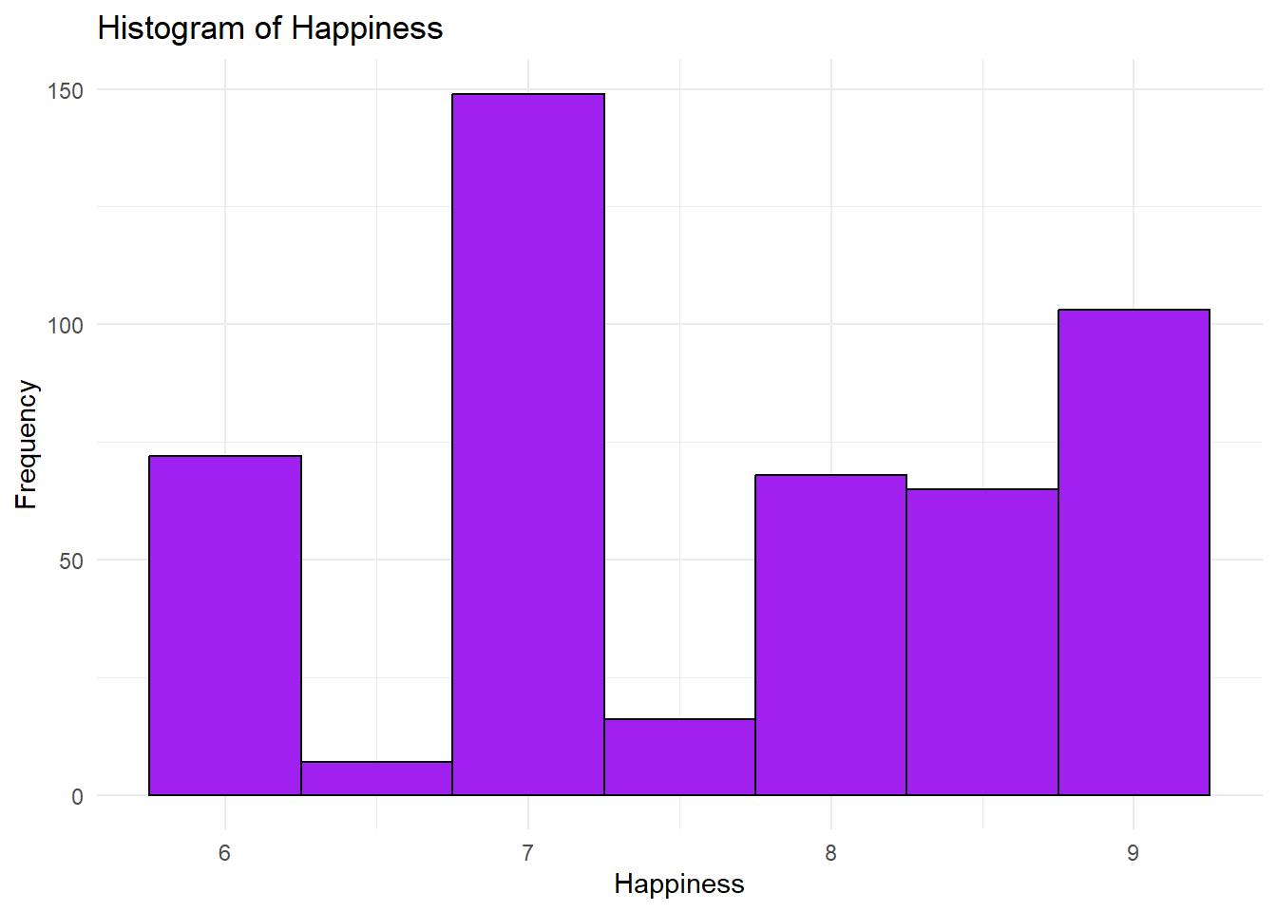
Figure 5
Histogram of Happiness
The histogram shows that Happiness values are moderately concentrated, with most observations falling between scores of 7 and 9. The distribution appears roughly symmetric, indicating that extreme low or high happiness scores are uncommon in the sample.
A boxplot was also generated to evaluate variability and potential outliers.
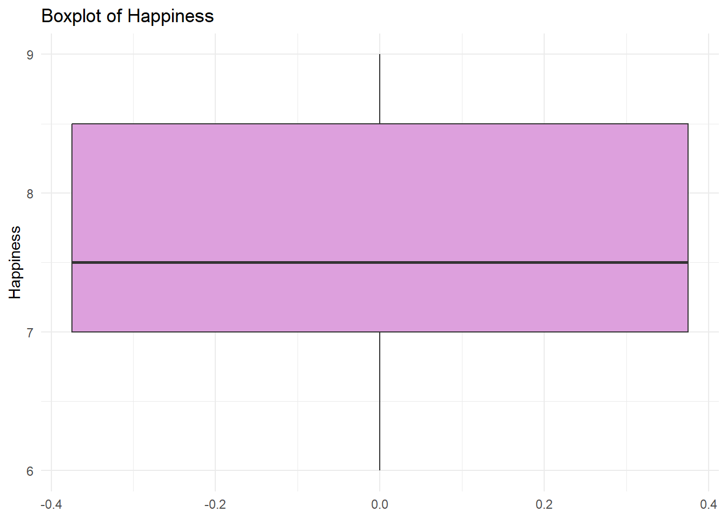
Figure 6
Boxplot of Happiness
The boxplot indicates a relatively small IQR, suggesting limited variability in Happiness scores. The median is positioned near the center of the box, and no substantial outliers are observed. This suggests that self-reported happiness levels are generally consistent across participants.
Categorical Variable Distributions
Bar charts were created for categorical variables to compare the frequency of observations across categories.
Gender Distribution
The distribution of Gender was examined using a bar chart.
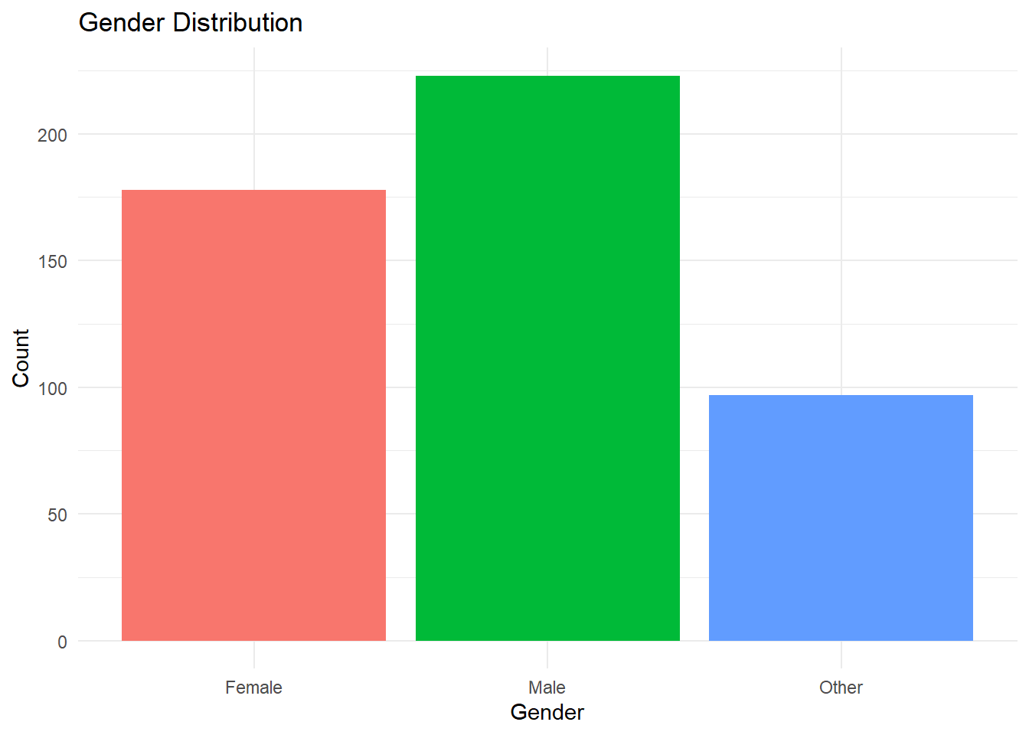
Figure 7
Gender Distribution
The bar chart shows that Male participants represent the largest proportion of the sample, followed by Female participants, with the Other category comprising a smaller share. While all gender categories are represented, the uneven distribution provides important context for interpreting relationships with other variables such as education and income.
Education Level Distribution
Educational attainment was visualized to assess the distribution of educational levels across the sample.
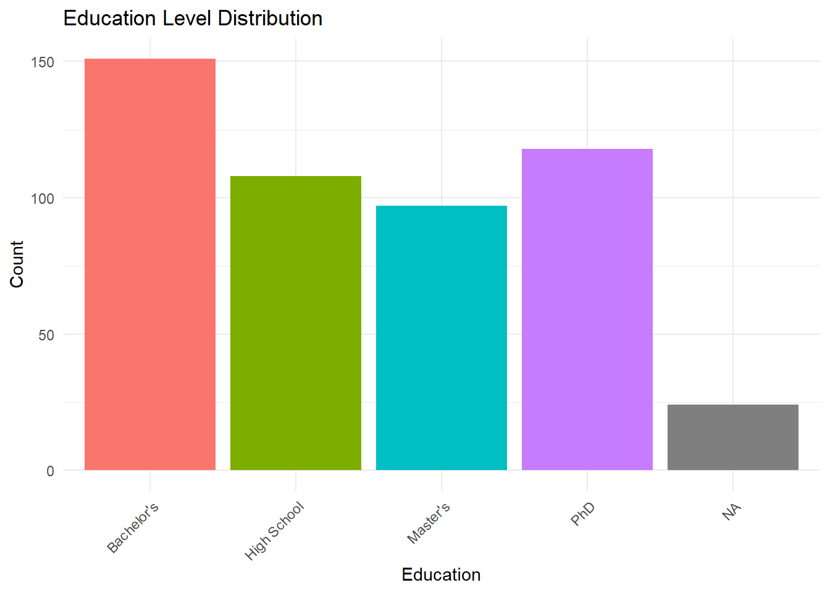
Figure 8
Education Level Distribution
The bar chart indicates that Bachelor’s degrees are the most common level of education in the dataset, followed by High School, Master’s, and PhD levels. This distribution suggests a concentration of participants at the undergraduate level, with fewer individuals represented at advanced degree levels.
Employment Status Distribution
Employment status was examined using a bar chart to summarize labor participation within the dataset.
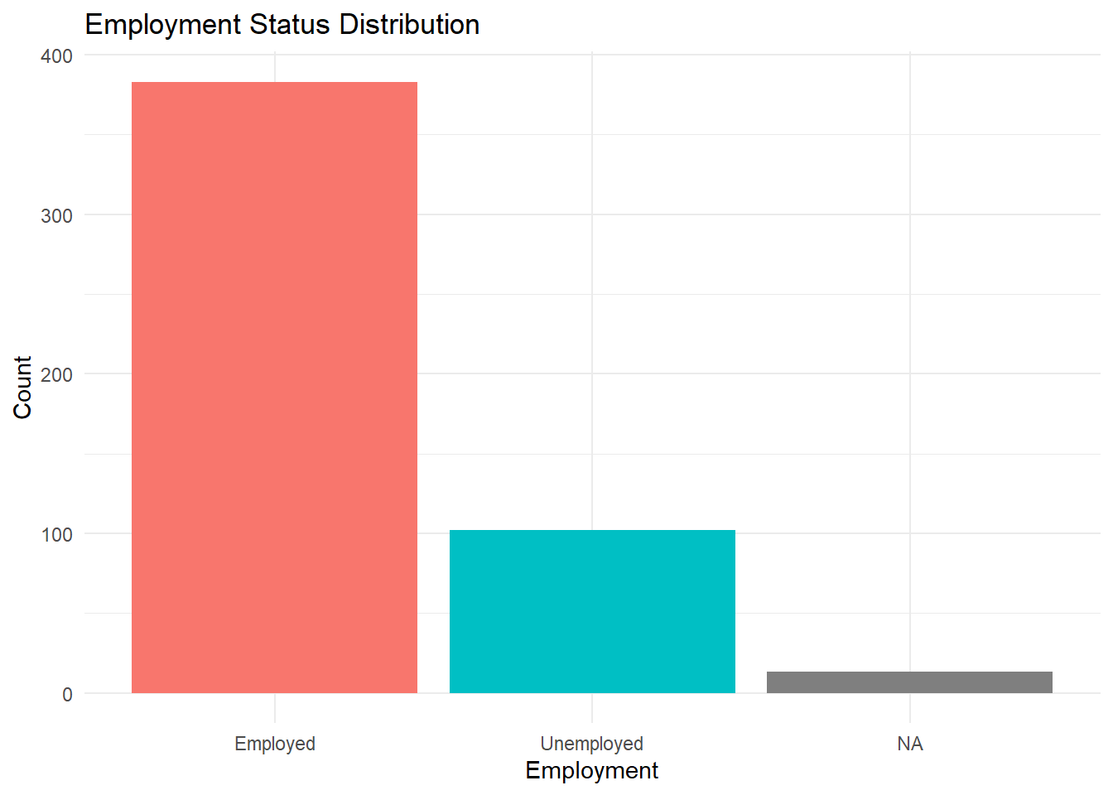
Figure 9
Employment Status Distribution
The bar chart shows that most participants are employed, with a smaller proportion classified as unemployed. This imbalance suggests relatively high labor force participation within the sample and provides important context for interpreting income-related findings.
Relationships Between Categorical Variables
To explore relationships between categorical variables, a contingency table and clustered bar chart were used to examine the association between Gender and Education level.
Table 1
Education Level by Gender
 | Female | Male | Other | Sum
Bachelor's | 138 | 4 | 9 | 151
High School | 10 | 26 | 72 | 108
Master's | 8 | 89 | 0 | 97
Phd | 0 | 103 | 15 | 118
Sum | 156 | 222 | 96 | 474

The contingency table presents the frequency of education levels across gender categories, enabling precise comparisons. The table reveals notable differences in educational attainment between genders, with Female participants primarily concentrated at the Bachelor’s level and Male participants more heavily represented at Master’s and PhD levels.
To complement the tabular summary, a clustered bar chart was generated.
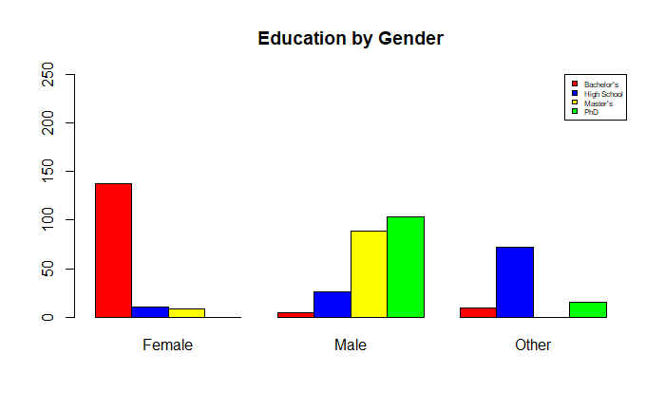
Figure 10
Education Level by Gender (Clustered Bar Chart)
The clustered bar chart visually reinforces the patterns observed in the table. Differences in educational attainment across gender categories are clearly visible, highlighting structural relationships within the dataset. These findings suggest that education may act as an important mediating factor in analyses involving employment and income.
Summary of Visual Findings
Collectively, the visual representations confirm and extend the insights obtained from descriptive statistics. Numerical variables differ substantially in variability, with Income showing the greatest dispersion and Age the least. Categorical analyses reveal meaningful associations, particularly between Gender and Education level. These graphical findings provide a strong descriptive foundation for subsequent inferential or predictive analysis.
Exploration Conclusions
The exploratory data analysis yielded several meaningful insights into the dataset's structure and characteristics. Numerical variables varied substantially in their level of dispersion, with Age showing very limited variability and Income exhibiting the greatest spread. This suggests that Age may be less influential in distinguishing outcomes within this sample, while Income represents a key variable for further analysis.
Visual analysis of categorical variables revealed notable relationships, particularly between Gender and Education level. Female participants were primarily concentrated at the Bachelor’s level, whereas male participants were more heavily represented at the Master’s and PhD levels. These differences highlight structural patterns that may influence related outcomes such as employment status and income.
No extreme anomalies or implausible values were identified after the data cleaning and structural correction process. Missing values were present but preserved intentionally to reflect the true condition of the data during exploratory analysis. Overall, the findings establish a strong descriptive foundation and support the selection of education, employment, and income variables for future inferential or predictive modeling.
Critique
Completing this exploratory analysis in R provided significant advantages over spreadsheet-based tools such as Excel. R offered greater flexibility, reproducibility, and efficiency, particularly when managing data cleaning, statistical computation, and visualization within a single workflow (Databricks, 2020).
While Excel may be sufficient for small datasets and simple analyses, the use of R dramatically reduces manual effort and the risk of human error. If the dataset were expanded from 500 to 50,000 observations, automated code-based analysis would scale efficiently, whereas a manual spreadsheet approach would become impractical.
From an organizational perspective, the ability to automate data processing and reporting using R can substantially increase productivity and support more timely, data-driven decision-making.

References
Databricks. (2020). Big book of data science (2nd ed.). Databricks.
https://www.databricks.com/resources/big-book-of-data-science
Kaliyadan, F., & Kulkarni, V. (2019). Types of variables, descriptive statistics, and sample size. Indian Dermatology Online Journal, 10(1), 82–86.
https://doi.org/10.4103/idoj.IDOJ_468_18
Knaflic, S. N. (2020). *Storytelling with data: A data visualization guide for business professionals* (2nd ed.). Wiley.
Wickham, H., Cook, D., & Hofmann, H. (2010). Graphical inference for exploratory data analysis. IEEE Transactions on Visualization and Computer Graphics, 16(6), 973–979. https://doi.org/10.1109/TVCG.2010.161

